**Table of Contents**

|  |  |  |
| --- | --- | --- |
| **S. No.** | **Chapter** | **Page No.** |
| 1 | Project Description | 2 |
| 2 | Source Code | 5 |
| 3 | Screenshots | 15 |

**CHAPTER -1**

**PROJECT DESCRIPTION**

**ALL ABOUT IPL**

The Indian Premier League, also known as IPL, is a professional Twenty20 cricket league in India. It is one of the most popular and lucrative T20 leagues in the world, featuring some of the best cricketers from around the globe.

This IPL webpage serves as a one-stop-shop for fans to stay up to date on everything related to the tournament and their favourite teams and players. The pages that are included in this website are a login page, register page, home page, about page, iconic moments page, history page and champion's page. Let us see an overview of all the pages one by one.

**LOGIN PAGE:**

This is an HTML document that contains a registration form for users to create an account. It includes fields for username, email, password, and confirm password.

The form includes client-side validation using JavaScript to ensure that the input fields are correctly filled in. The validation checks that the username is at least 6 characters long, the password is at least 8 characters long, the email field is not empty, and the password and confirm password fields match.

The CSS code is used to style the form and its elements. It sets the background color, font family, and other properties such as border radius and padding. The form is centered using the margin property.

**REGISTER PAGE:**

This is an HTML code for a login page. The page has a form with two input fields - one for the username and another for the password. The form also has a submit button that triggers a JavaScript function named checktheinputs() when clicked.

The function checks if the entered username and password match with any of the hardcoded values: "ranjithrit" and "k.r.b.11" or "sanjayit" and "19792004". If the entered values do not match with any of these, it displays an alert saying, "invalid username or password".

**HOME PAGE:**

The code provided is an HTML file containing the markup and styling for a web page. The web page appears to be about the Indian Premier League (IPL), a professional Twenty20 cricket league in India.

The CSS code in the style sheet defines some custom properties, including colors, and sets the background image of the landing section. It also styles the header and navigation bar, as well as the team images in the div element.

The body section includes a div element with a class of "landing" that contains a paragraph and a div element with a class of "teamimages". The paragraph instructs the user to click on the images to learn about the respective teams. The "teamimages" div contains 10 images, each linking to a Wikipedia page about a different IPL team.

**ABOUT PAGE:**

The page seems to have a navigation button that redirects to the "index.html" page, a center-aligned heading "ABOUT THIS PAGE", an image, and three subheadings with their respective descriptions. The subheadings are "ICONIC MOMENTS", "HISTORY", and "CHAMPIONS".

The webpage uses the "link" tag to connect to an external CSS file named "about.css", which is used to style the webpage. The "meta" tags define the character set, compatibility with Internet Explorer, and viewport settings for the webpage.

**ICONIC MOMENTS:**

The page includes five different moments, each accompanied by an image and a brief description. The first moment features Chris Gayle's explosive innings of 175 runs in just 30 balls, the second highlights Brendon McCullum's memorable first innings that changed the course of cricket, the third moment showcases Ravi Ashwin's controversial run-out of Jos Buttler using the Mankad method, the fourth moment describes a thrilling match between Kings XI Punjab and Mumbai Indians that required two super overs to determine the winner, and the fifth moment features a heated exchange between Gautam Gambhir and Virat Kohli during an IPL match.

**HISTORY:**

This is an HTML document with the title "history". It contains information about the history of the Indian Premier League (IPL), a professional Twenty20 cricket league in India. The document contains several headings, including "Background," "Foundation," "Expansions and Terminations," and several paragraphs of text with information about the league's history.

**CHAMPIONS:**

The page also has several images of IPL teams that won the championship in different seasons, starting from 2008 to 2022. Each image is accompanied by the name of the team, the name of the captain, and the year they won the championship. The images and the text are centered on the page for better presentation. The styling for the page is provided by a CSS file called "stats.css".

**GITHUB URL:**

[**https://github.com/ranjithrajkumar11/RANJITH-REPOSITORY.git**](https://github.com/ranjithrajkumar11/RANJITH-REPOSITORY.git)

**CHAPTER:2**

**SOURCE CODE**

**index.html**

<!DOCTYPE html>

<html lang="en">

<head>

<meta charset="UTF-8">

<meta http-equiv="X-UA-Compatible" content="IE=edge">

<meta name="viewport" content="width=device-width, initial-scale=1.0">

<link rel="stylesheet" href="style.css"></link>

<title>ALL ABOUT IPL</title>

</head>

<body>

<div class="landing">

<header>

<a style="color:gray;" class="title" href="index.html" style=font-family:Georgia, 'Times New Roman', Times, serif; class="logo">ALL ABOUT<div style="font-size: 2.3em; text-align: center;color:rgb(243, 55, 31);" > IPL</div></a><br>

<nav class="navi">

<button id="button" type="submit" class="navimg" style="background-color:gray; height: 70px"> <a href="login+java.html" style="height: 35px;font-size: 0.6em;width: 160px;"class="navimg" >BACK TO LOGIN</a></button>

<a style="color:rgb(20, 223, 213);" href="http://127.0.0.1:5500/stats.html" class="navimg" >CHAMPIONS</a>

<a style="color:rgb(20, 223, 213);" href="http://127.0.0.1:5500/pointstable.html" class="navimg">HISTORY</a>

<a style="color:rgb(20, 223, 213) ;" href="http://127.0.0.1:5500/iconic_moments.html" class="navimg">ICONIC MOMENTS</a>

<a style="color:rgb(20, 223, 213)"href="http://127.0.0.1:5500/about.html" class="navimg">ABOUT</a></nav>

</header><p style="color: antiquewhite ;align-items: center;">(click on the below pics to know the complete information about your favourite teams)</p>

<div class="teamimages">

<a href="https://en.wikipedia.org/wiki/Chennai_Super_Kings"><img src="MEDIA/csk.webp" alt="csk team" height="120px" width="200PX" class="pic"></a>

<a href="https://en.wikipedia.org/wiki/Delhi_Capitals"><img src="MEDIA/dc.webp" alt="dc team" height="120px"width="200px"class="pic"></a>

<a href="https://en.wikipedia.org/wiki/Gujarat_Titans"><img src="MEDIA/gt.webp" alt="gt team" height="120px"width="200px"class="pic"></a>

<a href="https://en.wikipedia.org/wiki/Kolkata_Knight_Riders"><img src="MEDIA/kkr.webp" alt="kkr team" height="120 px"width="200px"class="pic"></a>

<a href="https://en.wikipedia.org/wiki/Lucknow_Super_Giants"><img src="MEDIA/lsg symco.jpg" alt="lsg team" height="120px"width="200px"class="pic"></a>

<a href="https://en.wikipedia.org/wiki/Mumbai_Indians"><img src="MEDIA/mi.webp" alt="mi team" height="120px"width="200px"class="pic"></a>

<a href="https://en.wikipedia.org/wiki/Punjab_Kings"><img src="MEDIa/pbks sym.jpeg" alt="pbks" height="120px" width="200px"class="pic"></a>

<a href="https://en.wikipedia.org/wiki/Royal_Challengers_Bangalore"><img src="MEDIA/rcb.webp" alt="rcb" height="120px" width="200px"class="pic"></a>

<a href="https://en.wikipedia.org/wiki/Rajasthan_Royals"><img src="MEDIA/rr sym.webp" alt="rr" height="120px" width="200px"class="pic"></a>

<a href="https://en.wikipedia.org/wiki/Sunrisers_Hyderabad"><img src="MEDIA/srh sym.jpg" alt="srh" height="120px" width="200px"class="pic"></a></div>

<footer style="background-color: black;">

<p style="color: chartreuse;font-size: 1.5em;">&copy; all rights reserved by me only:)</p>

<p style="color:white;font-size: 2em;" >mail us : xyz123citchennai.net</p>

<p style="color:white;font-size: 2em;">contact us : 9876543210</p>

</footer>

</body>

</html>

**index.css**

:root{

--red:crimson;

--green:#53BF9D;

--yellow:#FFC54D;

--white:whitesmoke;}

.landing{

background-image: url('../MEDIA/CRICKET\ IPL.jpg');

background-size: cover;

background-position: center;

height: 105vh;}

header a{

text-decoration: none;

color:var(--yellow);

font-size: large;

padding: 0.7em;}

header{

display:flex;}

.logo{flex:3;

font-size: 300%;

color: var(--red);

}nav:hover{

text-decoration: underline;}

nav a{ flex:5;}div img{

padding:3.9em

}a:hover{

cursor: pointer;}

nav{ list-style-type: none;

margin: 0;

padding: 0em;}

nav a{float: rIGHT;

width: 200px;

height: 15px;

text-align: center;

}.title{

background-color: rgb(27, 38, 244);

font-size: 2.5em;

background-image: url("MEDIA/titlelogo.jpg");

background-size: cover;

height: 150px;

width: 200px;}

div a:hover{

color: cyan;}

.teamimages{

color: #53BF9D;}

form{

background-color: khaki;

padding: 3EM;}

.foot:hover{

color: rgb(168, 16, 16);}

.pic:hover{transform: scale(1.1);

box-shadow: 0 0 10px rgba(0,0,0,0.5);}

#imag{ float: right;}

.navimg:hover{

background-color: black;

color: rgb(21, 168, 185);

}.navimg{

font-size: 2em;

height: 50px;

}#button:hover{

background-color: black;}

**login+js.html**

<!DOCTYPE html>

<html lang="en">

<head>

<meta charset="UTF-8">

<meta http-equiv="X-UA-Compatible" content="IE=edge">

<meta name="viewport" content="width=device-width, initial-scale=1.0">

<link rel="stylesheet" href="logincss.css">

<title>Register</title>

</head>

<body>

<script type="text/javascript">

function validateinputs(){

var username=document.getElementById("username").value;

var email=document.getElementById("email").value;

var password=document.getElementById("password").value;

var cpass=document. getElementById("cpass").value;

if(username==null||username==""){

alert("please fill this username field");

return false;

}else if(username.length<6){

alert("username must contain more than 6 characters");

return false;

}

else if(password==null||password==""){

alert("fill the password field");

return false;

} else if(password.length<8){

alert("password must contain atleast 8 characters");

return false;

}else if(email==""){

alert("please fill this field");

return false;

}else if(cpass != password ){

alert("password is unmatched");

return false;

}

else{

alert("login success press ok ")

window.location.replace("index.html");

return false;

}

}</script>

<div class="container">

<form name="loginform"id="form" onsubmit =" return validateinputs()" action="index.html">

<h1>register</h1>

<div class="input-group">

<label for="username">Username</label>

<input type="text" id="username" name="username" placeholder="enter username">

<div class="error"></div>

</div>

<div class="input-group">

<label for="email">email</label>

<input type="email" id="email" name="email" placeholder="enter email id">

<div class="error"></div>

</div>

<div class="input-group">

<label for="password">Password</label>

<input type="password" id="password" name="password" placeholder="enter password">

<div class="error"></div>

</div>

<div class="input-group">

<label for="cpass">Confirm Password</label>

<input type="password" id="cpass" name="cpass" placeholder="confirm password">

<div class="error"></div>

</div>

<button id="input" type="submit"value="submit" class="btn" style="color: rgb(252, 250, 251); height: 2em;width: 12.5em ;height: 1.5em; font-size: 2em;border-radius: 100px; " onclick ="validateinputs()" >SUBMIT</button>

<center> <a href="login2.html" style="text-decoration: none;color: deeppink;">already an user</a> </center>

</div></body></html>

**register.html**

<!DOCTYPE html>

<html lang="en">

<head>

<meta charset="UTF-8">

<meta http-equiv="X-UA-Compatible" content="IE=edge">

<meta name="viewport" content="width=device-width, initial-scale=1.0">

<link rel="stylesheet" href="login2.css">

<title>EXISTING USER LOGIN</title>

</head><body><script>

function checktheinputs(){

var username=document.getElementById("username").value;

var password=document.getElementById("password").value;  
 if(username===null||username===""){

alert("please fill this username field");

return false; }  
 else if(password===null||password===""){

alert("please fill the password field");

return false; }

else if((username!=="ranjithrit" || password!=="k.r.b.11")&&(username!=="sanjayit" ||password!=="19792004") ){ alert("invalid username or password");return false; }

else{alert("signed in successful! press ok");return true; }}</script>

<h1>SIGN-IN</h1>

<form id="form" onsubmit="return checktheinputs()" action="index.html" ><div class="hi">

<label for="username">USERNAME</label>

<input type="text" id="username" name="username" placeholder="enter the username">

</div><div class="hi"> <label for="password">PASSWORD</label>

<input type="password" id="password" name="password" placeholder="enter the password"></div><button id="input"type="submit">SIGN-IN</button>

</html>

**login+js.css**

body{

background: rgb(251, 239, 8);

background: linear-gradient(0deg,rgba(34,193,195,1)0%,rgb(225, 10, 168)86%);

background-attachment: fixed;

margin:0;

font-family: 'poppins',sans-serif;

}

#form{

width: 400px;

margin: 20vh auto 0 auto;

background-color: whitesmoke;

border-radius: 5px;

padding: 30px;

background-image: cross-fade(12px) url(../MEDIA/Indian_Premier_League_Official_Logo.svg.png) ;

}

h1{

text-align: center;

color: #792099;

}

#input{

background-color: #792099;

color: wheat;

border: 1px solid #792099;

border-radius: 5px;

padding: 10px;

margin: 20px 0px;

cursor: pointer;

font-size: 20px;

width: 100%;

}

.input-group{

display: flex;

flex-direction: column;

margin-bottom: 15px;

}

.input-group input{

border-radius: 5px;

font-size: 20px;

margin-top: 5px;

padding: 10px;

border: 1px solid rgb(34,193,195);

}

.input-group input:focus{

outline: 0;

}

.error{

color: rgb(242,18,19);

font-size: 16px;

margin-top: 5px;

}

.input.group.success input{

border-color: #0cc477;

}

.input-group.error input {

border-color: rgb(206,67,67);

}

.btn:hover{

cursor: pointer;

text-decoration: aquamarine ;};

**CHAPTER 3:**

**SCREENSHOTS**

1. LOGIN PAGE-performs validation on password and confirm password.

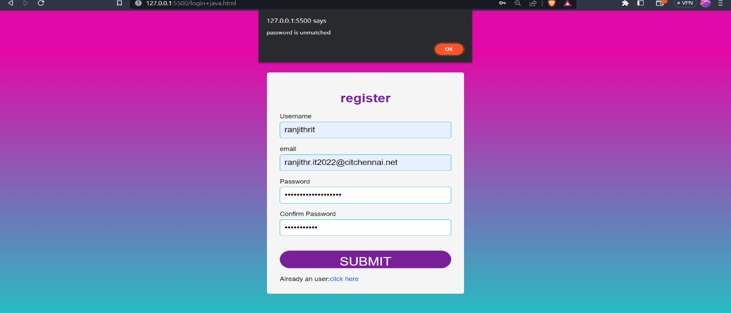

1. SIGN-IN-performs validation on existing username and password

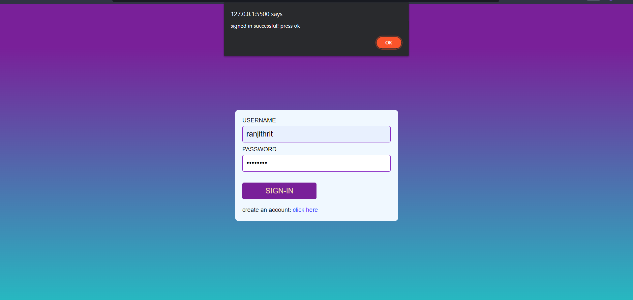

1. HOME PAGE-with many navigations

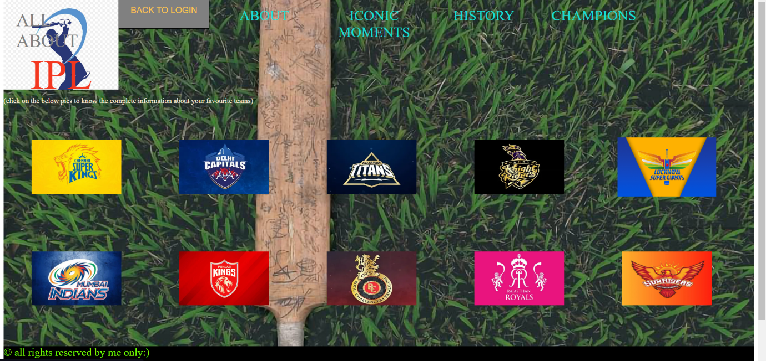

1. ABOUT THIS PAGE-gives the outline about my page

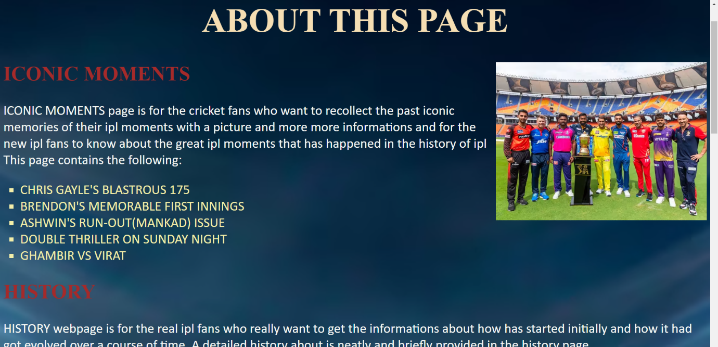

1. HISTORY-a page through navigation

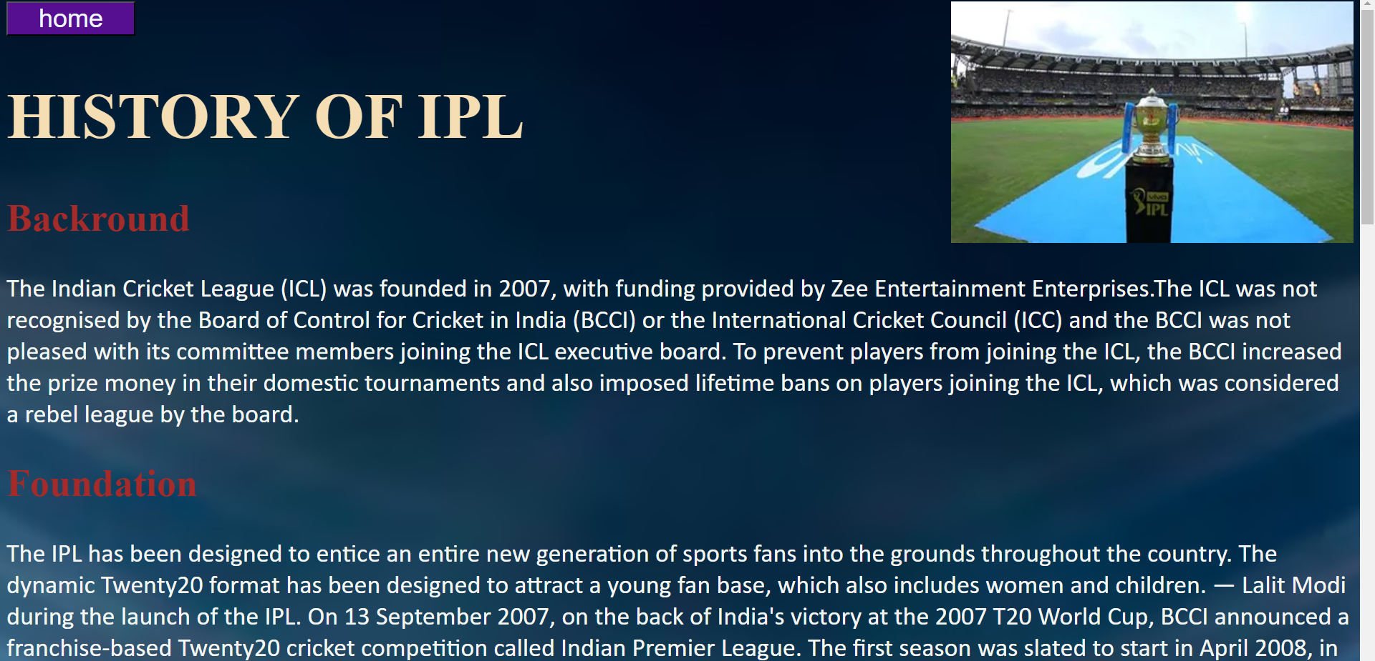

1. 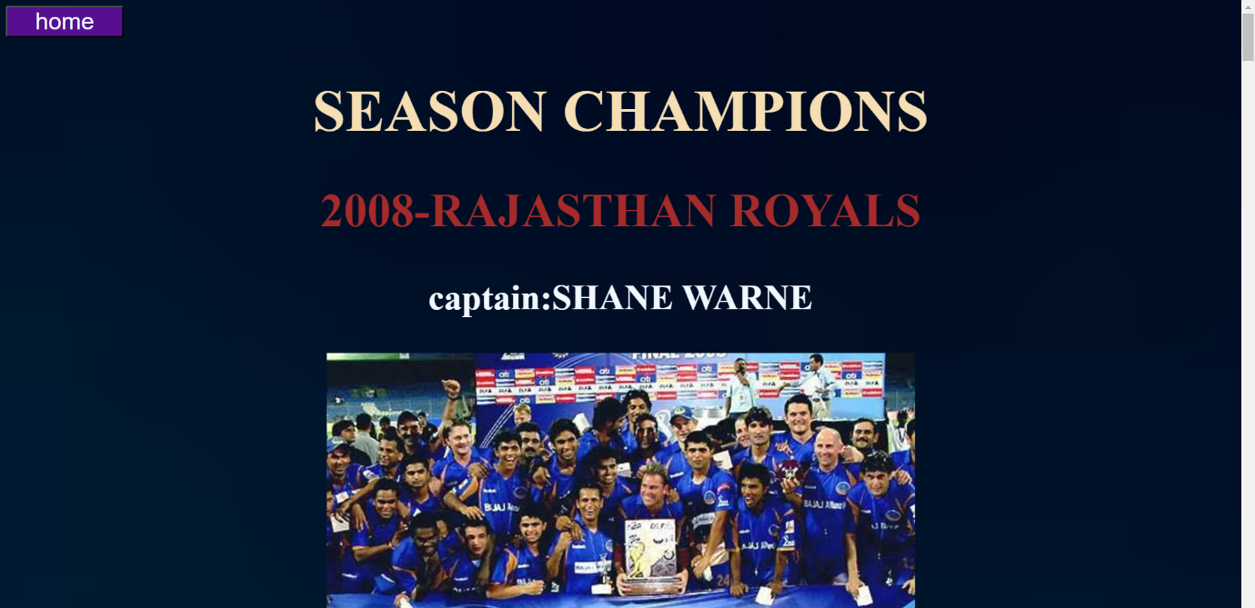CHAMPIONS-a page through navigation